Hydraulic Cylinder Replacement with Electric Rod-Style Actuator Application Worksheet
USE THE TOLOMATIC SIZING AND SELECTION SOFTWARE AVAILABLE ON-LINE AT www.tolomatic.com
or call Tolomatic at 1-800-328-2174. We will provide any assistance needed to determine the proper actuator for the job.
SYSTEM DETAILS
Please reference the Tolomatic Hydraulic Replacement Ebook for reference on methods to determine actuator needs. This worksheet will focus on the pressure method where pressures into and out of the cylinder are measured. It is also possible to use standard Electric Rod-Style sizing methods, but that typically requires more detailed application information than is available.
Video Recorded? ☐ Yes ☐ No If yes, if possible please provide to Tolomatic for confirmation
Location of pressure taps: ☐ At Control Valve ☐ Between Control Valve and Cylinder ☐ At Cylinder ☐ System Pressure Only
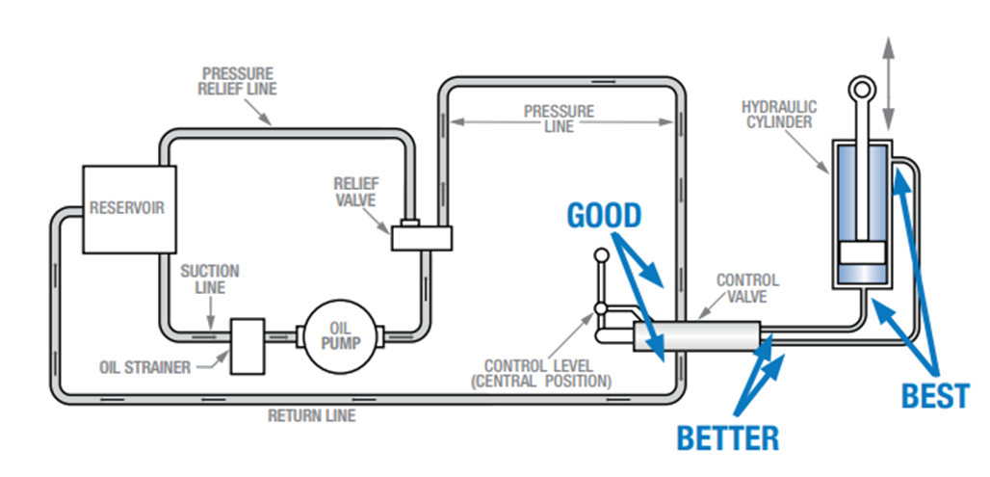
Cylinder Bore Diameter: Click or tap here to enter text. ☐ inches ☐ millimeters
Rod Diameter: Click or tap here to enter text. ☐ inches ☐ millimeters
Stroke Length: Click or tap here to enter text. ☐ inches ☐ millimeters
Relevant Pictures:

OPERATING PARAMETERS

System Pressure: Click or tap here to enter text. ☐ psi ☐ bar
Extend Working Pressure: Click or tap here to enter text. ☐ psi ☐ bar
Extend Back Pressure: Click or tap here to enter text. ☐ psi ☐ bar
Extend Move Time: Click or tap here to enter text. seconds
Retract Working Pressure: Click or tap here to enter text. ☐ psi ☐ bar
Retract Back Pressure: Click or tap here to enter text. ☐ psi ☐ bar
Retract Move Time: Click or tap here to enter text. seconds
Operating Environment (Describe Temperature, Contamination, Water, Etc.):
Click or tap here to enter text.
Additional Information:
Click or tap here to enter text.
Contact Information:
Click or tap here to enter text.
EM DETAILS
9900-4110
FAX 1-763-478-8080 |  | EMAIL help@tolomatic.com

