Maintenance Recommendations
for the Tolomatic Stainless Steel-IMA Actuator
on Raque Food Systems Fillers
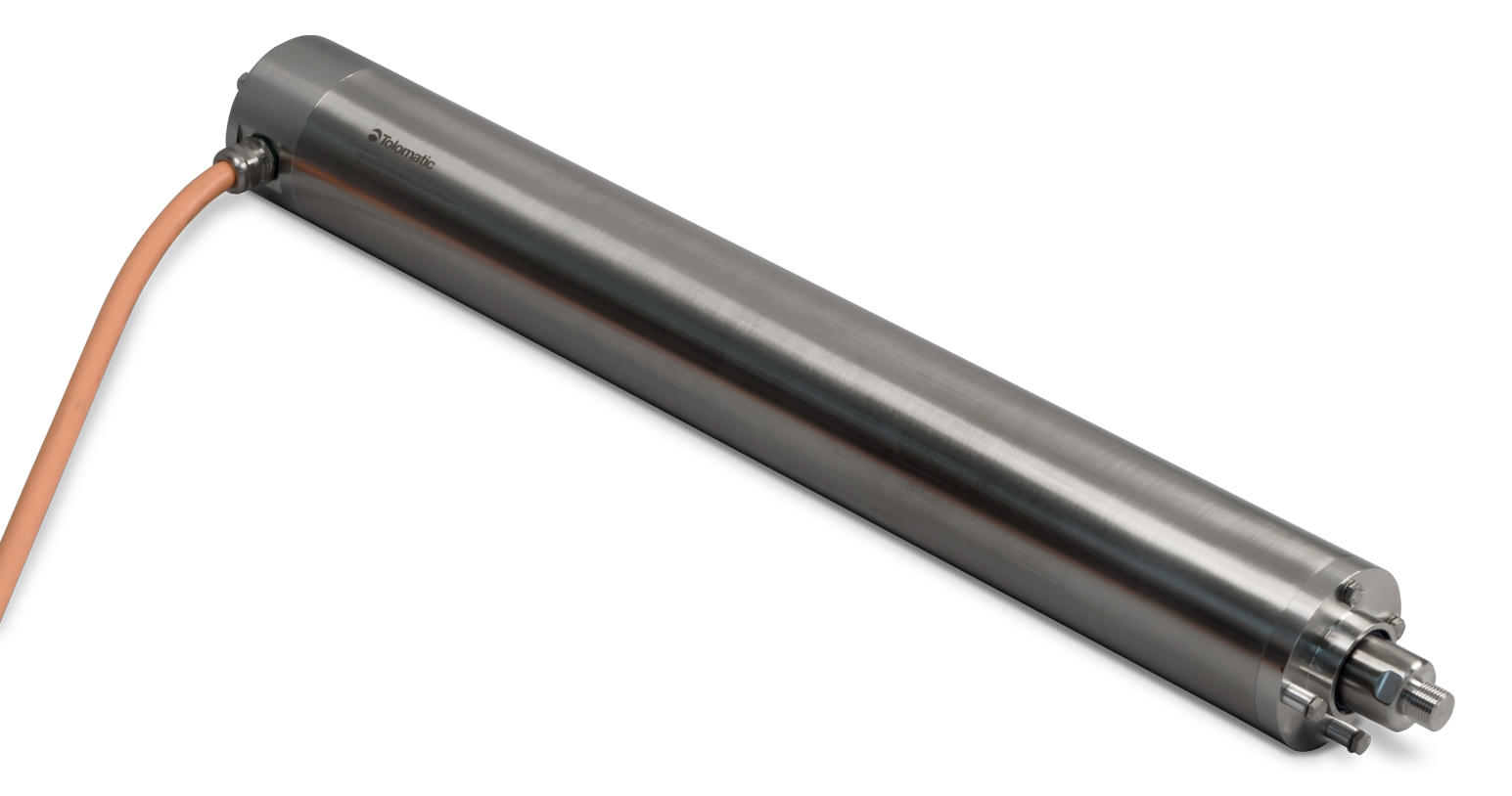

Links
IMA-S Manual 2700-4016

Introduction
This technical note is meant to inform and explain the process servicing and maintaining the rod seals for Tolomatic stainless steel IMA actuators. Depending on the cleaning agents used, frequency of cleaning, cleaning process, and the amount of buildup of particulates on the actuators, the performance of the seals will change over time. Proper maintenance to the assembly will prolong seal life and continue to protect the actuator from water ingress which can result in catastrophic damage to the unit.
Refer to document number 2700-4019 for additional instructions on repair and replacement of rod seals.
Refer to document number 2700-4016 for full maintenance, installation, and operation instructions.

Wash-down Recommendations

- Cleaning should only be done by qualified personnel
- Tolomatic requires the actuator to be stationary and de-energized during cleaning
- It is recommended that the actuator be fully retracted during cleaning
- Follow IP69K wash-down standards for pressure, proximity and temperature. Violating the
- IP69K standards could be detrimental to the life of the actuator
- Tolomatic prohibits the use of friction style cleaning such as a wire brush. Wash-down and
wipe down cleaning are the only approved cleaning methods
- Minimum acceptable concentrations of cleaning chemicals should be used to successfully
sanitize equipment. Consult Tolomatic for chemical compatibility
- A rinse down of the actuator is required after the cleaning process to minimize seal exposure to sanitizing chemicals
- Do we want to suggest reading another document from us or Raque for full wash down instructions? Or is the list above the full list of instructions from the document?

Seal Lubrication Recommendations
- Re-lubrication of rod seals with Mobil SHC Polyrex 462 after each cleaning is recommended.
- A small amount of grease (SHC Polyrex 462 or Raque Food Systems approved piston seal grease) should be applied to the external surface of the actuator thrust rod and rod end seal. This should be applied at the same time grease is applied to the piston seal(s) of the Raque Filler.
- Periodic visual inspection of the thrust rod and front seal is recommended
  - Refer to document number 2700-4019 for additional instructions on repair and replacement of rod seals.

Recommendations
- Seals should be replaced every 25 million inches of travel.

Early Replacement Recommendations
- 50% reduction in seal replacement interval if food product is expected to be present on thrust rod during operation
- 50% reduction in seal replacement interval if wash-down frequency is 3+ time per day. Periodic re-lubrication of rod seals with Mobil SHC Polyrex 462 will increase the life of the seals
- 50% reduction in seal replacement interval if high sanitizing chemical concentrations are used
- Seal exposure time is important to consider, a rinse after sanitizing is recommended to remove residual sanitizing chemicals

Seal Cartridge Replacement Procedure (For units installed after 9/01/2020)
NOTE: Before starting any maintenance activities, make sure that the supply power is shut OFF

Secure actuator in vertical rod up orientation.

Note: It is important not to damage the rod’s finish; any nicks, cuts, groves, or roughness on the road can cause water ingress and/or premature seal failure.

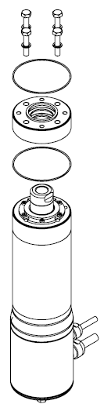
Loosen Hex Bolts and remove Front Head and O-Ring between Seal Cartridge and actuator body.

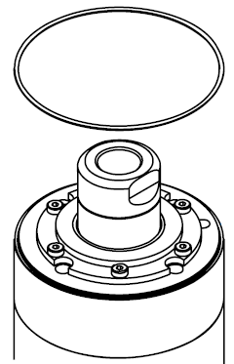
Inspect new O-Ring and install into groove of actuator body.

Do Not over stretch the O-Ring, the O-Ring is designed to 'snap' into groove

O-Ring doesn't require lubrication due to the nature of the material

Remove new Seal Cartridge from packaging. Verify that grease is present between the rod seals. If no grease is present, the seals should be lubricated with SHC Polyrex 462 before cartridge is installed

Place the new Seal Cartridge onto the Thrust Rod and push flush with the body of the actuator

Verify O-Ring is still in its groove before tightening Fasteners

Install all 4 sealing Washers and Fasteners

Torque Fasteners in cross pattern to the specifications listed in the table below

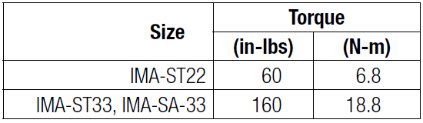
Check Fastener torque to ensure full compression of O-Ring

Verify O-Ring is ‘flush’ to the surface and that Sealing Washers are seated below each of the Fasteners

Lubrication

For lubrication of the actuator screws, refer to Tolomatic document 2700-4016

