Field Service Recommendations
for the Tolomatic Stainless Steel-IMA Actuator
on Raque Food Systems Fillers
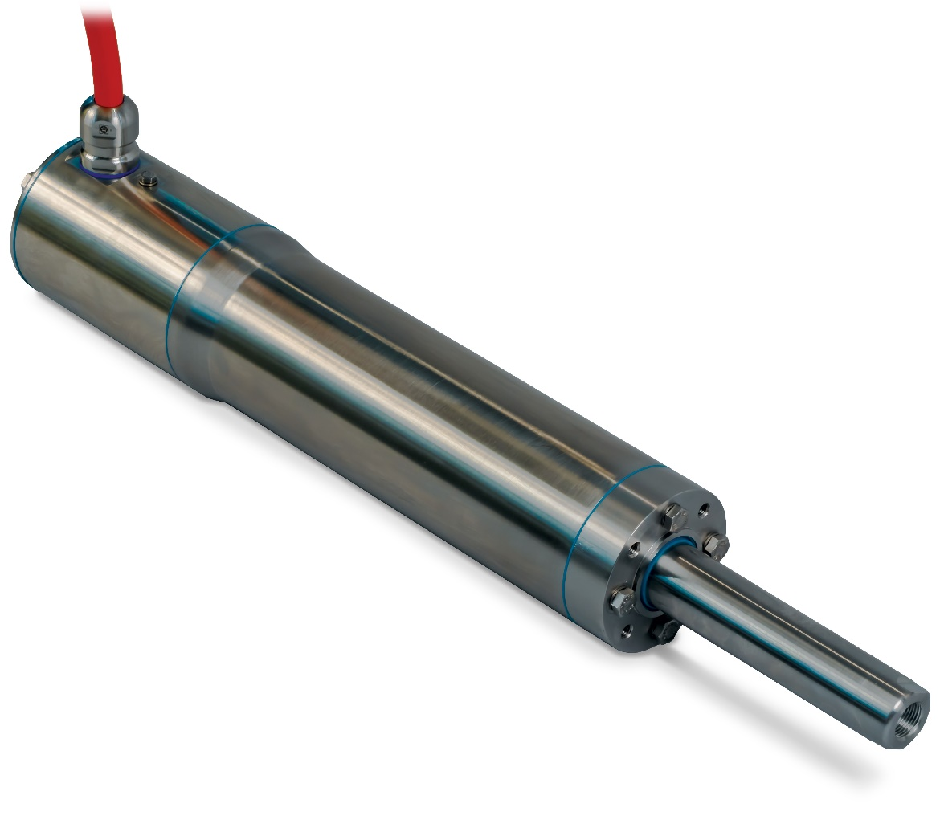

Links
IMA-S Manual [2700-4016_00]

Introduction
This technical note is meant to inform and explain the process of having a seal cartridge installed on the Tolomatic Stainless Steel IMA actuators. These actuators are installed on Raque Food Systems Filler Machines. This design change was implemented to remove the existing seal arrangement with one that is field replaceable. It will also further prevent water intrusion leading to extended service life.
No immediate action is required. As of 09/01/2020 Tolomatic implemented a seal change to further enhance serviceability and sealing performance.
OLD HEAD ASSEMBLY
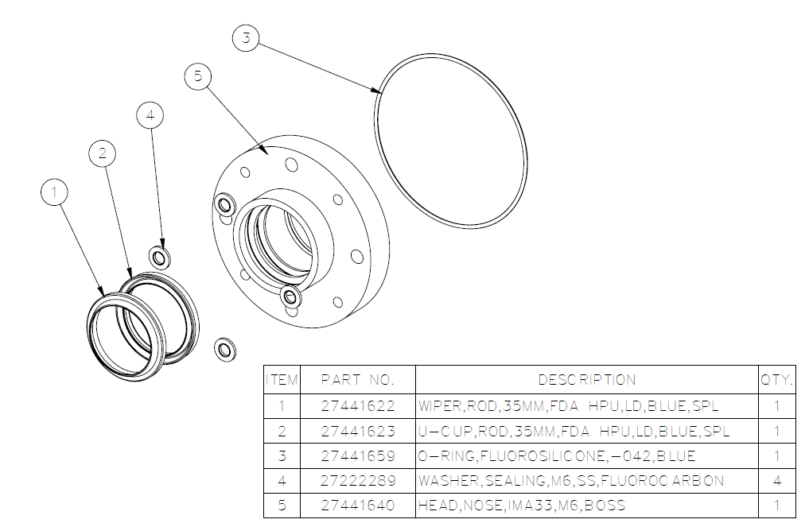

NEW HEAD ASSEMBLY
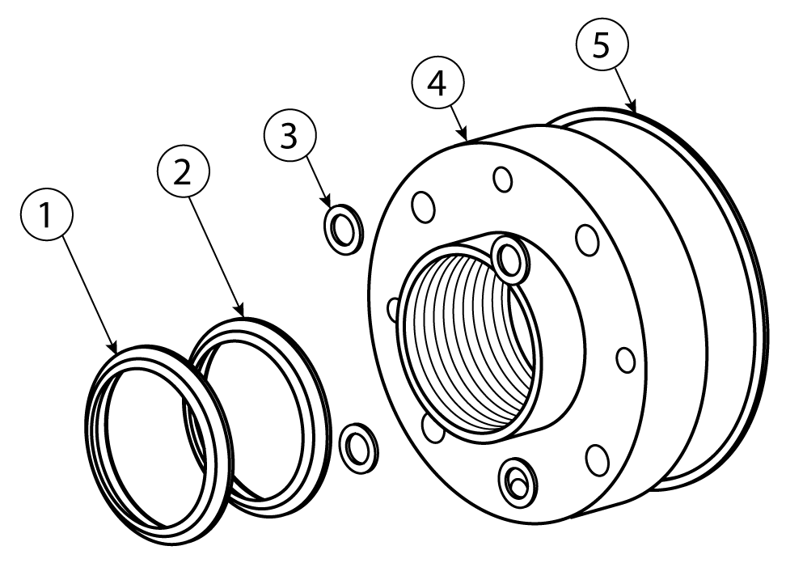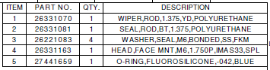
Existing Raque Food Systems customers can have this seal assembly implemented onto existing units. To do so they must be sent back to Tolomatic for installation. Implementation of this new seal cartridge is not required for proper continual operation of existing assemblies. This new arrangement allows for field replacement of seals as part of a regular preventative maintenance schedule.

Procedures

No Action is required for existing assemblies

For Tolomatic IMA-S actuators in service prior to 12/31/2018
  - Obtain an authorized RMA# (Return Materials Authorization Number) from Raque Food Systems
    - Please be prepared to provide part number and serial number at the time of requesting RMA number
  - Return unit directly to Tolomatic for refurbishment with field serviceable seal cartridge.
    - Units must be shipped to the following address with proper marking of the RMA number
Tolomatic Inc.
Attn: RMA# Rxxxx
3800 County Road 116
Hamel, MN 55340
USA
**Refurbishment Fee(s) may apply from Raque Foods**

  - For units requiring additional repair please advise Raque Food Systems of this at the time of requesting an RMA

    - If actuator is not functioning properly, obtain an authorized Tolomatic RMA# from Raque Food Systems, and return unit directly to Tolomatic for evaluation
    - Units must be shipped to the following address with proper marking of the RMA number
Tolomatic Inc.
Attn: RMA# Rxxxx
3800 County Road 116
Hamel, MN 55340
USA

    - If actuator can be repaired, Raque Food Systems will provide a quote for repair, including the field serviceable seal cartridge.
    - If actuator is found to be non-economical to repair, Raque Food Systems will provide a quote for an updated replacement actuator

Tolomatic IMA-S actuators in service after 01/01/2019
  - If actuator is functioning properly, obtain an authorized Tolomatic RMA# from Raque Food Systems, and return unit directly to Tolomatic for refurbishment with field serviceable seal cartridge.
    - Please be prepared to provide part number and serial number at the time of requesting RMA number
  - Refurbishment will be covered under warranty by Raque Food systems

For units manufactured after 09/01/2020

Order a new replacement seal cartridge number XXXX through Raque Food Systems

  - If actuator is not functioning properly, obtain an authorized Tolomatic RMA# from Raque Food Systems, and return unit directly to Tolomatic for evaluation.
    - Please be prepared to provide part number and serial number at the time of requesting RMA number
    - Units must be shipped to the following address with proper marking of the RMA number

Tolomatic Inc.
Attn: RMA# Rxxxx
3800 County Road 116
Hamel, MN 55340
USA

    - If actuator is found to be non-economical to repair, Raque Food Systems will provide a quote for a replacement actuator, including the field serviceable seal cartridge.
    - If actuator can be repaired, Raque Food Systems will provide a quote for repair, including the field serviceable seal cartridge.

WASH-DOWN RECOMMENDATIONS
      - Cleaning should only be done by qualified personnel.
      - Tolomatic requires the actuator to be stationary and de-energized during cleaning.
      - It is recommended that the actuator be fully retracted during cleaning.
      - If sanitation procedures require operation of the actuator, then provisions are necessary to prevent direct spraying of the thrust rod and seal as well as water dripping onto the rod and seal
      - Follow IP69K wash-down standards for pressure, proximity and temperature. Failure to do so may shorten the service life of the unit or void the manufacturer’s warranty

      - Tolomatic prohibits the use of friction style cleaning tools such as a wire or bristle type brush
- Wash-down and wipe down cleaning are the only approved cleaning methods
      - Minimum acceptable concentrations of cleaning chemicals should be used to successfully sanitize equipment
- Consult Tolomatic for chemical compatibility.
      - A non-chemical rinse of the actuator’s exterior surfaces after the cleaning process are required to minimize prolonged exposure of the external seals to sanitizing chemicals.

4. SEAL REPLACEMENT RECOMMENDATIONS
4.1 General Application Scenario
• One wash-down per day following wash-down guidelines above.
• Actuator is not experiencing side load during operation.
• Thrust rod is not being contaminated by food product or other materials during operation.
• Hardware is not damaged and is still in operating condition.
• Maximum velocity and acceleration limits are not exceeded.
• Actuator is operating within specified temperature range.

4.2 Recommendation
4.2.1 Recommended Replacement Interval
- Tolomatic recommends replacing rod seals after every 25 million inches of travel.

4.2.2 Early Replacement Recommendations
- 50% reduction in seal replacement interval if food product is expected to be present on thrust rod during operation.
- 50% reduction in seal replacement interval if wash-down frequency is 3+ time per day.
- 50% reduction in seal replacement interval if high sanitizing chemical concentrations are used
- Seal exposure time is important to consider, a rinse after sanitizing is recommended to remove residual sanitizing chemicals.

4.2.3 General Notes
- Periodic re-lubrication of rod seals with Mobil SHC Polyrex 462 or Tolomatic approved lubricants will increase the life of the seals.
- Periodic visual inspection of thrust rod and front seal is recommended.
- It is important to avoid any getting any nicks or scratches on the thrust rod. This can impact the units ability to seal against ingress of moisture and contamination and shorten service life

5. SEAL CARTRIDGE REPLACEMENT PROCEDURE

5.1 Units manufactured after 9/1/2020

- Secure actuator in vertical rod up orientation.
- Visually inspect thrust rod for damage. If the thrust tube is damaged the new rod seals will not function properly.
- Loosen Hex Bolts and remove the seal cartridge from the actuator body.
- Remove new Seal Cartridge Assembly from packaging. Verify that grease is present between the rod seals. If no grease is present, the seals should be lubricated with SHC Polyrex 462 or Tolomatic approved lubricant before the cartridge is installed.
- Verify that the O-Ring is installed in the back face of the seal cartridge.
- Place the new Seal Cartridge onto the Thrust Rod and push flush with the body of the actuator.
- Install all 4 NEW Sealing Washers on the existing fasteners.
- Torque Fasteners in cross pattern to the specifications listed in the table below.
  - Select correct fastener torque from the table below for proper O-ring compression
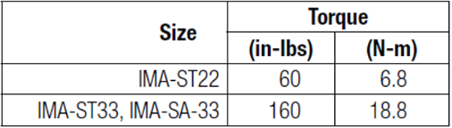

- Verify Sealing Washers are installed below each fastener head.
- Package and ship used seal cartridge to Tolomatic for evaluation.

5.2 Units manufactured prior to 9/1/2020
- Obtain an authorized Tolomatic RMA# from Raque Food Systems, and return unit directly to Tolomatic for evaluation.
    - Units must be shipped to the following address with proper marking of the RMA number

Tolomatic Inc.
Attn: RMA# Rxxxx
3800 County Road 116
Hamel, MN 55340
USA

6. ROD AND SEAL LUBRICATION

NOTE: Before starting any maintenance activities, make sure that the supply power is shut OFF.

CAUTION: DO NOT FILL WITH GREASE!

6.1 THRUST ROD AND ROD END WIPER SEAL
A small amount of grease (SHC Polyrex 462 or Raque Food Systems approved piston seal grease) should be applied to the external surface of the actuator thrust rod and rod end seal. This should be applied at the same time grease is applied to the piston seal(s) of the Raque Filler.

